Mitchiko Azarcon-Tiongson Profile

Mitchiko Azarcon-Tiongson started dubbing at the age of 21. She first dubbed Anime in to Filipino and then moved on to dub live Filipino, Portuguese, Mexican Telenovelas into English.

Her career started with Fushigi Yuugi, voicing Nuriko and Soi. She’s also known for voicing Kurapica and Biscuit Kreuger in HunterX Hunter and Hikaru and Caldina from Ray Earth. All of which were dubbed in Filipino.

Some Anime, which she dubbed in English were: Knight Hunters where she voiced Sakura and Karen, To Heart as Akari and Burn Up Excess as Maya. These Anime were locally sold in the Philippines by MagnaVision.

Others like Dangaioh and Protector Yui, and Niko: The Journey to Magika [where she played the lead] were dubbed in English and were shown and/or distributed internationally. Niko: The Journey to Magika, in particular was shown in the Tribeca Film Festival in New York.

Mitchiko also does voice overs for commercials both for Radio and Television.

Mitchiko still dubs and has progressed to supervising and directing entire projects where she now manages talents [coordinate schedules and directs dubbing/ADR sessions].

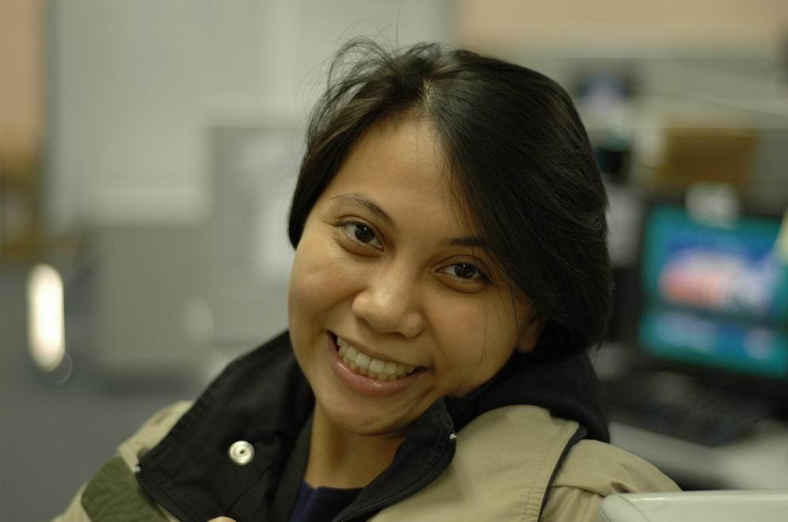

Cell number: 0917-8987761
Email: mitchiko.tiongson@gmail.com
Website: http://mitchikoazarcon.wix.com/the-vox-guild
Skype ID: mitchikotiongson
Mitchiko A. Tiongson
Experience: | 2014 Adarna House 109 Scout Fernandez cor  Scout Torillo Sts, Brgy.  Sacred Heart, Quezon City  - Gave voice (English) to an original book character for an audio book  TITLE:  Ang Pambihirang Buhok ni Raquel [Post production]  2012-2013 Ambient Media Carmel House  29 Buencamino St.,  Alabang, Muntinlupa City  - Gave voices (English) to original animated characters shown on television or released in video both local and international  TITLE:  PADDLE POP [Post production]  2010 - Present ALTA PRODUCTIONS 10th Flr., Sagittarius Bldg.  111 HV dela Costa,  Salcedo Village, Makati  - Gave voices (English) to live characters from Filipino Telenovelas released internationally.  - Supervised and Directed English dubbing sessions  TITLES:  DYESEBEL Co-Supervised w/ Joam Santiago]  LOSING HEAVEN  LEGACY [Co-Supervised w/ Joam Santiago]  CHILDREN IN MY HEART  2011 – PRESENT SOUND WEAVERS 28th Flr., City Land Tower  Pasong Tamo, Makati  - Gave voices (English) to live characters from Portuguese Telenovelas released internationally.  - Translated / synched scripts of Portuguese Telenevolas for dubbing  TITLES:  LEI  SAMSON and DELILAH  ESTHER  REI DAVID  JOSEPH  TOBOTS  WARA STORE  2010 – Present ABS CBN  - Gave voices (English and Tagalog) to animated or live characters shown on television or released in video both local and international  - Translated / synched scripts of Filipino Telenevolas for dubbing  TITLES:  INA, KAPATID, ANAK [English Dubbed]  ONCE UPON A TIME S1 & S2  PLEASANT GOATS  MARY  KANG CHI  BE CAREFUL WITH MY HEART  LOVE RAIN  MARA / CLARA [English Dubbed]  CITY HUNTER  TOTALLY SPIES  EL TIGRE  DORA THE EXPLORER  IT STARTED WITH A KISS 1 & 2  LOVE OR BREAD  2010 CUTTING EDGE  - Gave voices (English) to animated characters released in video internationally.  TITLE:  Niko: The Journey to Magika [as Niko]  Nov. 1999 – 2013 TELESUCCESS 405 QUADSTAR BLDG.  Ortigas Ave., San Juan,  Green Hills  Voiceover Talent  - Gave voices (English and Tagalog) to animated characters shown on television or released in video both local and international  - Some Filipino projects include:  Fushigi Yuugi – Nuriko, Soi, Miboshi and the Grandma, etc.  Gadget Boy Kanipan – Gadget the little robot, Rabiory, etc.  Monster Rancher – Undine  Cats Eye - Ai  Bakuretsu Hunters – Villain for 3 episodes  Grandoll – Lead’s best friend and villain  Ray Earth – Hikaru and Caldina  HunterXHunter – Kurapica, Biscuit Kreuger, Mench, Zuchi, MCs, etc.  Doremi – Aiko  Solty Rei  Hamtaro – Penelope, Jingle  Full Metal Panic – Theresa Testarosa  Fullmetal Alchemist – Alphonse Elric, Izumi Curtis  D-Grayman – Road Camelot, Miranda Lotto, Hevlaska, Lulu Bell  Fairy Tail – Happy, Juvia, Cana, Levi, Evergreen  - Some English projects include:  Gantz – Tae Kojima  Knight Hunters – Sakura and others  To Heart – Akari  Lupin the III – Female guests  Dangaioh – Female cast  Dangizer – Lead  Corrector Yui – Teacher  Star Scramble – Female cast  Burn Up Excess – Maya and other female cast  March 2000 – Present TELESUCCESS 405 QUADSTAR BLDG.  Ortigas Ave., San Juan  Scriptwriter  - Translated English Anime scripts into Tagalog suitable for dubbing  - Projects include: Fushigi Yuugi, Monster Rancher, Cat’s Eye, Gadget Boy Kanipan and Doremi  - Wrote scripts in English suitable for dubbing for video and international release.  - Project included: Dangaioh, To Heart and Pangako  April 2000 – Present Audio Media/Hit Productions/Cinderella/  Cutting Edge/Loudbox/Sound Design  - Did Voice Overs and sang (English/Filipino) for Radio and TV Commercials and Educational Projects  Radio Commercial Voice Over  - Voiced over for the commercials of Cinderella: Halloween Sale and Loca for Polka Sale  - Voiced over for Nelicom Patis Commercial  - Voice over for Café Puro  - Voice over for Talk and Text in different Dialects  - TVC Voice Over for Rejoice  - Voice over for Pepsi  - Voiced over for Chuckie [Filipino and Multiple Dialects]  - Rejoice  - Claritin  - Bambini  - Globe  Video Educational Program  - Bodhi [Post Production]  2010 - 2013 SDI / 20 PLUS / Animax  - Gave voices and vocals (English and Tagalog) to animated and live characters shown on television or released in video both local and international  - Supervised and Directed dubbing / singing sessions  ENGLISH TITLES:  Grachi  Tears to Tiara  Toward the Terra  Tower of Druaga  Inuyasha  Origin  Red Garden
Education | 1995 – 2001 Bachelor of Arts Speech Communication & Theater Arts  University of the Philippines, Diliman
Skills | Singing, acting, public speaking, speech writing, organizing/facilitating group discussions and voice acting.  Languages:  English: Spoken – Very proficient. Written – Very proficient  French: Spoken – Knowledgeable Written – Knowledgeable  Filipino: Spoken – Very proficient Written – Very proficient

References :

Arleen Bacay
Producer
Alta Productions
10th Flr., Sagittarius Bldg,
111 HV dela Costa, Makati City

Dr. Antoinette Bass-Hernandez
3rd Flr., Dept. Speech Communication and Theater Arts
University of the Philippines, Diliman
920-5301 Ext. 7450

May Munoz Diwa
2808 Sound Weavers
Cityland Towers, Pasong Tamo, Makati City

